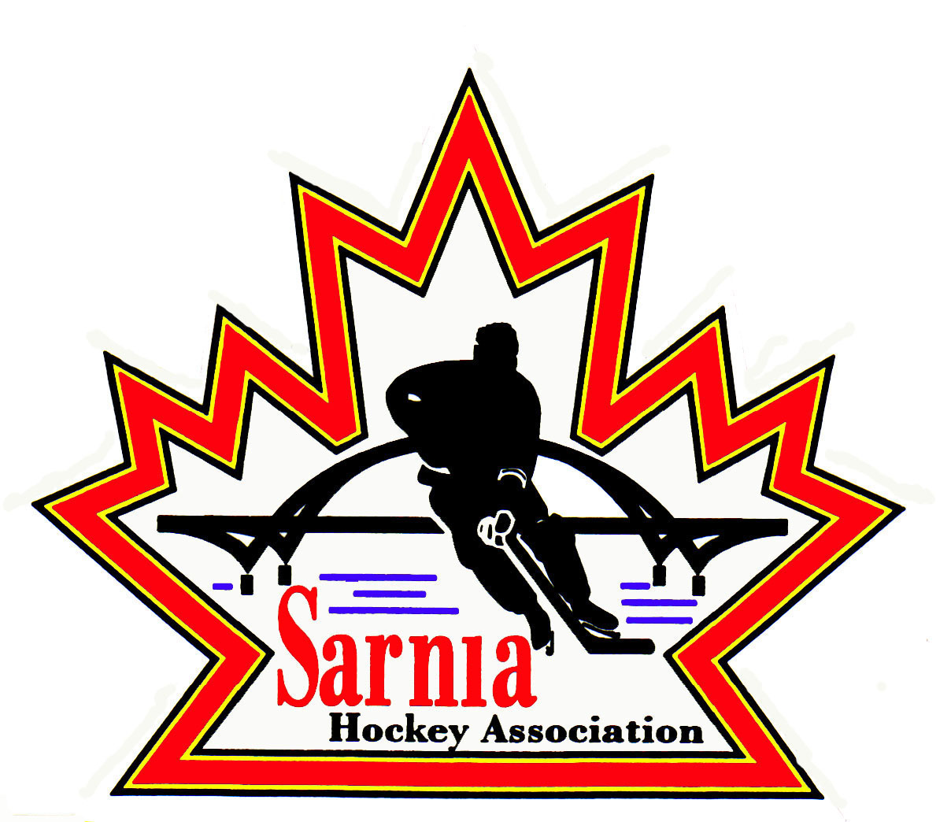

Sarnia Hockey Association

Minutes | Date: MAY 7, 2024 | time 7:00 pm

Meeting called by | Paul Walsh, Chairperson
Type of meeting | AGM
Secretary | Kelly Lane, Recording Secretary

Welcome | Paul Walsh, Chair welcomed everyone and called the meeting to order at 7:05 pm.

ATTENDANCE | Andrew Beasley, Jacquie Beasley, Jerry Bernardo, Alister Brown, Emily Brown, Darren Chevalier, Justin Day, Paul Douglass, Ian Dunn, Chuck Ewart, Terry Gray, Kelly Lane, Linda Lauzon, Don McGugan, John Mellor, David Penner, Wayne Scarrow, Lesley Taylor-Smith, Kevin Taylor, Barb Walsh, Paul Walsh  Regrets: Tom Babcock, Jeff Fogal, Pat Forbes, Kyle Mellor, Tim Turner  Guests: David Kraayenbrink, John Ritchie, Pete Tavabis, Tyson Ellwood, Mellissa Forbes, Michelle Page, Brent Campbell

ACCEPTANCE OF MINUTES | Rev  MOTION #240507-001  “That the AGM Minutes from 02 May 2023 be accepted as presented.” (J. Mellor/Chevalier)  Carried

TREASURER’S REPORT | AUDITOR REPORT: 2022/23 SEASON  - The audited financials to fiscal year end April 30, 2023 represent the financial that were overseen by our previous Treasurer Ted Pendle.  - Audit was conducted by J.W. Michael McDonough who has completed audits for SHA for many years. This was helpful with the transition to our new Treasurer.  - The review was conducted to obtain reasonable assurance that the financial statements as a whole are free from material misstatement, whether due to fraud or error and to issue an auditor’s report that includes the auditor’s opinion.  - Several standard risks were identified but no issues to report.  - Registration revenue was up by $181,000 from the previous year. Tournament revenue was also up by over $135,000.  - The increase in participation also had an equivalent effect on expenses with an increase seen in ice fees, equipment and supplies, final days expenditures and tournament related expenses.  - Looking at the fiscal year in its entirely, the year ended with a deficit of $53,815 (versus a deficit of $48,865 the year prior), however the Association remains in a healthy position with a net asset positive balance of $356,762. This takes into account savings and GIC investments.  MOTION #240507-002  “That the 2022/23 Auditors Report be accepted as presented.” (E. Brown/Dunn)  Carried  MOTION #240507-003  “To appoint J.W. McDonough Professional Corporation as the auditor of record for Sarnia Hockey Association 2023/24 audit.” (E. Brown/Ewart)  Carried

CONSTITUTION | BYLAW #1  - It will be available on our website.  - Consents to be signed at first meeting after our AGM.  MOTION #240507-004  “To accept the April 2024 Sarnia Hockey Association Bylaw #1 as our Constitution going forward.” (B. Walsh/Lauzon)  Carried
  CURRENT BY LAW PROPOSED CHANGES | REASONING
  Chair to President  Vice Chair to Vice President  Chair  Remove majority of Board Positions/Description and Committee descriptions | All OHF, Alliance and individual Minor Hockey Associations all use President and Vice-President terminology.  President will act as Chair.  Detailed descriptions will be added to Policy.
  ONCA REQUIREMENTS/  RECOMMENDATIONS | REASONING
  Definitions required | Added to By-law
  Number of Directors changed to a range versus current list of 33 | 20-40 is proposed range to allow for changes in number of Directors outside of Constitution
  Chair as a separate role | Must be listed on record with Ministry
  Quorum for Board of Directors 51% of minimum number of directions (20)=11 | Just said 11 in quorum with no basis for number
  Quorum for Members meeting is 11 | We can set our own quorum, staying with current of 11
  Director Qualification | Qualification updated to include ONCA requirements e.g. An individual, not to be found incapable and not have the status of bankrupt.
  Director Consent | Sign at next AGM and proposing annual signing to include conflict of interest. Include Conflict of Interest as well.
  Members rights enhanced | Removal of membership notification and chance to respond
  Telephonic or electronic meetings allowed | Response to times when in person meetings cannot take place
  Dissolution of Association | Procedure added as Article
  Fundamental Changes to Association | Procedure added as Article
  Records | ONCA requires certain records to be prepared and maintained (articles, bylaws and amendments. Minutes from board, committee meetings and member meetings. List of directors and members going back 6 years (including names, start date, end date, addresses (email), suitable accounting records.  ONCA. Workbook utilized.

REC LEAGUE DIRECTOR | Rec Program witness significant grown and success across various initiatives aimed at fostering the love for hockey and enhancing player development. The season was marked by expansion, innovations and remarkable achievements that showcased the vibrancy and dedication of the hockey community in Sarnia.  Expanding Opportunities for Learning, Introducing New Players & Creating the Sarnia Hockey Footprint:  One of the standout highlights of the season was the expansion of the instructional and initiation programs. Breaking down a barrier to older players eager to learn the fundamentals of hockey. Spearheaded by Shawn Zettel and Blake Morrison, the Foundations Program provided invaluable opportunities for players aged 4-8 to develop their skills under expert guidance. A big highlight from Foundations – Blake and Shawn were able to run 2 separate Jamborees in the program time block (with lessons learned from the 1st and applied to the 2nd).  The Sarnia Hockey Footprint is our organization using its influence, talent, and assets to selflessly build a stronger overall hockey community. Young athletes are always going to remember their first coach or first friendships – they will especially remember their first time stepping on the ice….and that was with Sarnia Hockey.  - The First Shift program (led by Kevin Taylor) brought in approximately 47 new to hockey players from all over Lambton County (some brand new to Canada). 33 Boys and 14 Girls that had never experienced organized hockey were provided equipment, ice time and coaching further enriching the sport's grassroots and building our hockey community. Mooretown Minor Hockey, Petrolia Minor Hockey, Sarnia Junior Lady Sting and Sarnia Hockey can all look forward to seeing some new faces this up coming season and they will be wearing a First Shift Jersey.  - Another achievement that was not evident until the very end of the season, Shawn Zettel took on a Foundations team of All Girls . This “Footprint” initiative has helped develop a strong bond between a group of young female athletes in our community. I am happy to say they have made the jump to go play with the Sarnia Junior Lady Sting in a more competitive environment.  Introduction to Gameplay:  The U6/7 League, under the leadership of Brendan Douglass, introduced close to 100 young players to the thrill of gameplay through modified cross-ice games. This approach not only made the game more accessible but also enhanced skill development and fostered a love for competition among the budding athletes.  Success in Traditional Leagues:  The traditional league programs experienced resounding success under the guidance of dedicated coaches and team staff. Program Directors Justin Day (U9), Dave Penner (U11), Pat Forbes (U13), Darren Chevalier (U15), and Jerry Bernardo (U18/21) provided exemplary leadership, nurturing the talents of players across various age groups.  Community Engagement and Participation:  With close to 800 players and 300 volunteers, the Rec Leagues buzzed with activity throughout the season, culminating in nearly 880 games played. The enthusiasm and commitment of both players and volunteers were instrumental in creating a thriving hockey community in Sarnia.  Triumph at Alliance Championships:  Sarnia Hockey teams made a commendable showing at the Alliance Championships. The U9 Gray and U11 Blue teams reached the finals, demonstrating their prowess on the ice. Additionally, the U13 Black team clinched the championship title in their division, a testament to their hard work and skillful play. Though the U15 and U18 teams were eliminated during the round-robin stage, their participation showcased the competitive spirit and determination of Sarnia's young athletes.  Innovations in Player Development:  Along with our ongoing Goalie Skills Program that runs Fridays with Paul Burgess, the introduction of the “direct to the player strategy”, goalie coaching, skating exercises & training further elevated player development within the Recreational Program. Credit to Paul Burgess (Burgess Goalie Consulting), Riley Collins(6x4 Goaltending) and Darren Rogers(Power Edge Pro), the implementation of and techniques provided a solid foundation for skill enhancement, improving opportunities to learn and promising a brighter future for hockey development in Sarnia.  Looking ahead, Sarnia Hockey remains committed to nurturing talent, fostering inclusivity, and promoting the values of sportsmanship and camaraderie within the community. Next season we are looking forward to:  - First Shift for Fall (Nov, Dec, Jan)  - Further expansion of Foundations and adding positions for players up to U11 Age  - Continuation of traditional Rec League Programming and post Pandemic growth  - Adding to the Recreational Program with a SKILL COMPETITION (for everybody) in February called the Frozen February Skills Competition  With each season building upon the successes of the past, the future of hockey in Sarnia shines bright.

REP TEAM SUMMART | A/AA  U10 A and U16 A were Alliance Champions.  B/BB  U11 won their Alliance Championship.  U13 and U16 finished in second place. Both teams had great seasons and got stronger as the season went along.  U14 and U15 made the semi finals.  U8 is Jamboree style.  U10 and U12 battled hard but didn’t make it to the Championships.

PRESIDENT’S COMMENTS: | VOLUNTEER AWARDS:  A number of awards were given out at our Volunteer Appreciation Event.  Plaques were given out and pictures were taken.  Recreational Coach of the Year:  U6 – Nathan Jeffrey  U7 – Brandon Biggers  U9 – Scott Grant  U11 – Tyler McBean  U13 – Aaron Kilbreath  U15 – Ryan Sharpe  U18 – Ken Pollock  U21 – Glen Fenwick  Representative Teams Coach of the Year  A/AA – Cori Savo  B/BB/MD – Fred VanReenen  Representative Teams Manager of the Year  A/AA – Samantha Rath  B/BB – Christian Willemsen  Volunteer of the Year:  Jerry Bernardo  The Chair also thanked the Board as well as the volunteers that helped make this a successful season.

NEW BUSINESS | BOARD CHANGES:  3 Members of our Board are leaving. The President recognized and thanked them for their previous years of service. Departing members include Justin Day, Shawn Zettel and Harry Chadwick.  There are 2 members who are changing portfolios. The Chair thanked those that are staying on our Board.  MOTION #240507-005  “That all decisions made and actions taken by the Directors and Officers of the Association between the dates May 2, 2023 and May 7, 2024 be approved, ratified and confirmed.” (P. Walsh/K. Taylor)  Carried  POSITIONS UP FOR ELECTION:  Secretary will make single vote ratify the board as there was single candidates:  POSITIONS THAT REQUIRE ELECTION:  Vice Chair Representative Teams- Harry Chadwick, Paul Walsh  Director of Recreational League U18/21 – Darren Chevalier, John Ritchie  Clinics Director – Jacquie Beasley, John Ritchie  Registration Director – Lesley Smith-Taylor, Melissa Forbes  Development/Skills Director – Jeffrey Needham, Dwayne Viggers  Those that wished to speak were offered that opportunity.  MOTION #240507-006  “That Wayne Scarrow and Emily Brown collect and count the votes.” (B. Walsh/K. Taylor)  Carried  Votes were cast by members that had attended at least two SHA meetings. Votes were tallied  and the successful candidates were Paul Walsh, Darren Chevalier, Jacquie Beasley, Lesley Smith-Taylor and Jeffrey Needham.  RATIFICATION OF THE NEW BOARD:  President - Paul Walsh  Vice President Administration - Barb Walsh  Vice President Representative Teams – Paul Walsh  Recording Secretary - Kelly Lane  Director B/BB/MD – Chuck Ewart  Director Recreational League U18/21- Darren Chevalier  Director Recreational League U13 - Pat Forbes  Director Recreational LeagueU9 - Blake Morrison  Equipment Director Recreational League - Alister Brown  Tournament Director Silver Stick - Kyle Mellor  Clinics Director – Jacquie Beasley  Registration Director – Lesley Smith-Taylor  Sponsorship Director Representative Teams - Wayne Scarrow  Photography Director - John Mellor  1 Year Appointment:  Vice President Recreational League – Jerry Bernardo  Director Recreational League Foundations - VACANT  Direction Recreational League U15 - VACANT  Development/Skills Director – Jeffrey Needham  Director Mental Health – Tom Babcock  Director at Large (AAA Rep) – Tim Turner  Director at Large (AAA Rep) – Cris LaPointe  Director at Large (Select Teams) – Don McGugan  Director at Large (Silver Stick) – Paul Douglass  Director at Large – VACANT  Director of Fundraising – Bonny Marcy  Alliance Rep Council – Paul Walsh  Alliance Rec Council – Jerry Bernardo  VACANT POSITIONS- 1 YEAR APPOINTMENTS:  Director Rec League - Foundation  Recreational Director - U15  Director at Large  Contact Wayne Scarrow or Paul Walsh if interested in those positions.  MOTION #240507-007  “That the ballots be destroyed.” (B. Walsh/Lauzon)  Carried  Welcome to new board members and current board members who are continuing on for 2024 season.
  POSITION | CURRENT MEMBER | APPLICANTS
  Chairperson | Paul Walsh | Paul Walsh
  Vice Chair Representative Teams | Harold Chadwick | Harold Chadwick, Paul Walsh
  Vice Chair Administratioon | Barb Walsh | Barb Walsh
  Recording Secretary | Kelly Lane | Kelly Lane
  Director B/BB/MD | Chuck Ewart | Chuck Ewart
  Director Recreational League UB18/21 | Jerry Bernardo | Darren Chevalier, John Ritchie
  Director Recreational League U13 | Pat Forbes | Pat Forbes
  Director Recreational League U9 | Justin Day | Blake Morrison
  Equipment Director – Recreational League | Alister Brown | Alister Brown
  Tournament Director -Silver Stick | Kyle Mellor | Kyle Mellor
  Clinics Director | Jacquie Beasley | Jacquie Beasley, John Ritchie
  Registration Director | Lesley Smith-Taylor | Lesley Smith-Taylor, Michelle Forbes
  Sponsorship Director-Representative Teams | Wayne Scarrow | Wayne Scarrow
  Photography Director | John Mellor | John Mellor
  1 YEAR APPOINTMENTS
  Vice Chair Recreational League | VACANT | Jerry Bernardo
  Director Recreational League-Foundations | Blake Morrison/Shawn Zettel
  Director Recreational League U15 | Darren Chevalier
  Development/Skills Director | VACANT | Jeffrey Needham, Dwayne Viggers
  Director Mental Health | VACANT | Tom Babcock
  Director at Large (AAA Rep) | Tim Turner | Tim Turner
  Director at Large (AAA Rep) | Cris LaPointe | Cris LaPointe
  Director at Large (Select Teams) | Don McGugan | Don McGugan
  Director at Large (Silver Stick) | Paul Douglass | Paul Douglass
  Director at Large | VACANT
  Director of Fundraising | Bonnie Marcy | Bonnie Marcy
  Alliance Rep Council | Harry Chadwick
  Alliance Rec Council | Kevin Taylor | Jerry Bernardo

adjournment | MOTION #240507-008  “That the meeting be adjourned.” ( P. Douglass/Mellor)  Carried

Paul Walsh Kelly Lane
President Secretary

